Jinda Li

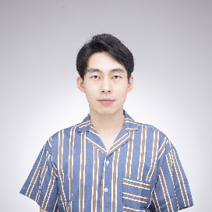



Email：neil_jnda@outlook.com

Portfolio：<https://neiljnda.github.io/>

LinkedIn：<https://www.linkedin.com/in/jinda-li/>

Phone：+358-4578-361-861





EXPERIENCE

They Are YouDesigner, Programmer (team of 8) 2022.02-2022.06

A stealth action game demo

Best Student Game of Finland, Second Place, Bit1 Competition 2022

Based on the concept of “kill to transform”, designed characters and skills and created part of the gameplay content.

Programmed main gameplay content including character control, transformation logic, combat system, logic/graphics of vision, etc.

Naraka: BladepointGame Designer Intern 2021.05-2021.07

24 Entertainment, NetEase Games

**Following up on the operations and version updates around the time of game release**, participated in the design of weapons. Organized the animation requirement document to optimize the art asset pipeline.

Optimized character movement experience of character movement in complex environments. Maintained and updated clear and readable level standards documentation.



SKILLS

Experienced a wide range of games for around 10000+ hours. With **10-year experience in League of Legends**, intimately familiar with its MOBA gameplay, operation strategies, and e-sport events. As a **hardcore player of mobile games** (Genshin Impact, Onmyoji), has a good understanding of promotion, operation, commercialization and community management.



Adobe Suite



Microsoft Office



Python



Unity/C#

**Proficiency in data analysis with Python**. In a course project, predicted the sales of Steam games by applying machine learning. **Understand the basic logic of the market and products.** In an innovation and entrepreneurship contest during my undergraduate, researched competitors, identified the market positioning, wrote the business plan, and finally won the national first prize as the respondent.



Blender



English/Chinese

**Good communication and management skills with a team spirit.** During my undergraduate, planned and organized an evening gala as director, and coordinated a team of about 30 staff, attracting 300+ spectators.



EDUCATION

**Game Design and Production**, Aalto University

Master of Science (A-Scholarship) 2021-present

GPA: 4.73 / 5

**Electrical Engineering**, Southeast University

Bachelor of Engineering 2016-2020

GPA: 3.56 / 4